Assignment 2

- We write up the utlity functions for the mixed strategies and check if they intersect in the pure strategies
$$V_{1}\left(p,q\right)=\left(2-2p\right)·q+p·\left(1-q\right)=$$
Player 1 sets p to maximize V for every q
We differentiate with respect to p for player 1
$$\frac{∂V_{1}}{∂p}=-2q+1-q=1-3q$$
If larger than 0 we set price as high as possible and vice versa
If equal to 0 player 1 is indifferent to the pricelevel
This implies a best response function
$$B_{1}\left(q\right)=\left\{\begin{aligned}0 for q<\frac{1}{3} \\ \left[0,1\right] for q=\frac{1}{3} \\ 1 for q>\frac{1}{3}\end{aligned}\right.$$

We do the same for player 2

$$V_{2}\left(p,q\right)=p·q+\left(1-p\right)\left(1-p\right)=1-q-p+2·q·p$$
$$\frac{∂V_{2}}{∂q}=-1+2p$$
If larger than 0 player 2 chooses to showcase if lower chooses not to showcase
In mixed strategies this would be a q=1 or q=0
Again this gives the best response function
$$B_{2}\left(p\right)=\left\{\begin{aligned}S for p<1/2 \\ S or D for p=\frac{1}{2} \\ D for p>\frac{1}{2}\end{aligned}\right.$$

Translated to probabilities
$$B_{2}\left(p\right)=\left\{\begin{aligned}1 for p<1/2 \\ \left[0,1\right] for p=\frac{1}{2} \\ 0 for p>\frac{1}{2}\end{aligned}\right.$$

We draw these 2 different best response diagrams

First with player 2 not being able to mix
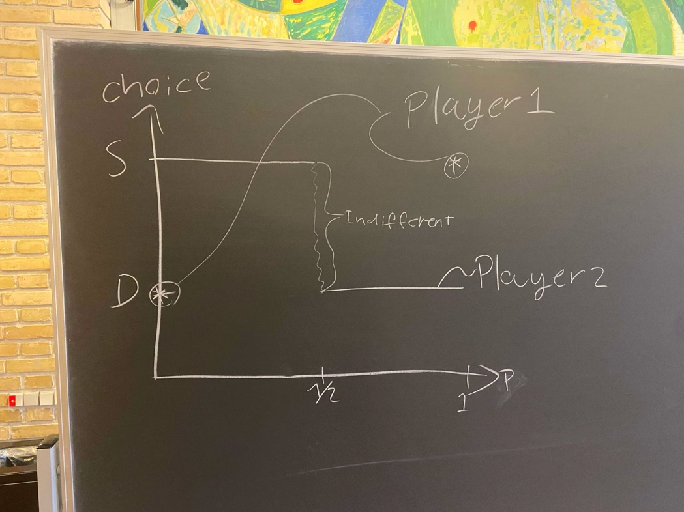
Since player 2 is not able to mix player 1’s response function is not defines between the 2 choices and thus the best response functions never intersect and thus we have no nashe EQ

Second when he can mix strategies 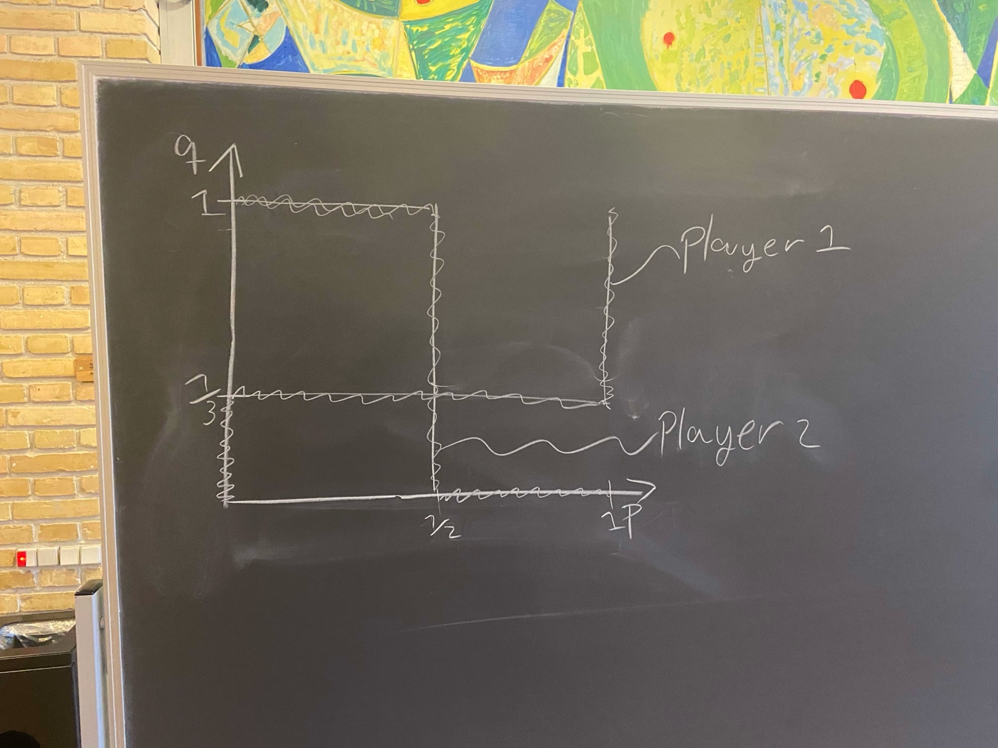
When looking at the best response diagram we identify NE by intersections of the best responses

We have an intersection at $\left(p,q\right)=(\frac{1}{2},\frac{1}{3})$
Where we have a mixed nash eq
$$MSEQ=\{\left(p=\frac{1}{2}\right);\left(q=\frac{1}{3}\right)\}$$

We calculate each players expected payoff in Nash
$$V_{1}\left(\frac{1}{2},\frac{1}{3}\right)=\left(2-\frac{2}{2}\right)·\frac{1}{3}+\frac{1}{2}·\left(1-\frac{1}{3}\right)≈0,6666667$$
$$V_{2}\left(\frac{1}{2},\frac{1}{3}\right)=1-\frac{1}{3}-\frac{1}{2}+2·\frac{1}{3}·\frac{1}{2}=0,5$$

